Imperial Brown Ale
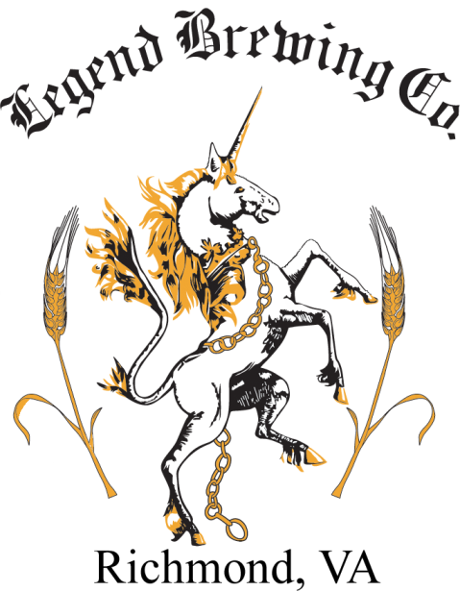
Legend 20th Anniversary Imperial Brown Ale

The addition of the word Imperial to any beer is a clue that it is a beefier more robust version of its predecessor. Legend Imperial Brown Ale is a souped up version of our flagship Brown Ale, showcasing its flavors and characteristics in bolder quantities.
More body, more malty flavors, more Hops and more ABV. Seven types of barley malt yield a deep, rich body evoking biscuit, caramel, chocolate and coffee flavors. Our house ale yeast adds a level of fruity esters, and a moderate hop bite combines with alcohol warmth for a balanced finish. ABV 8.3

