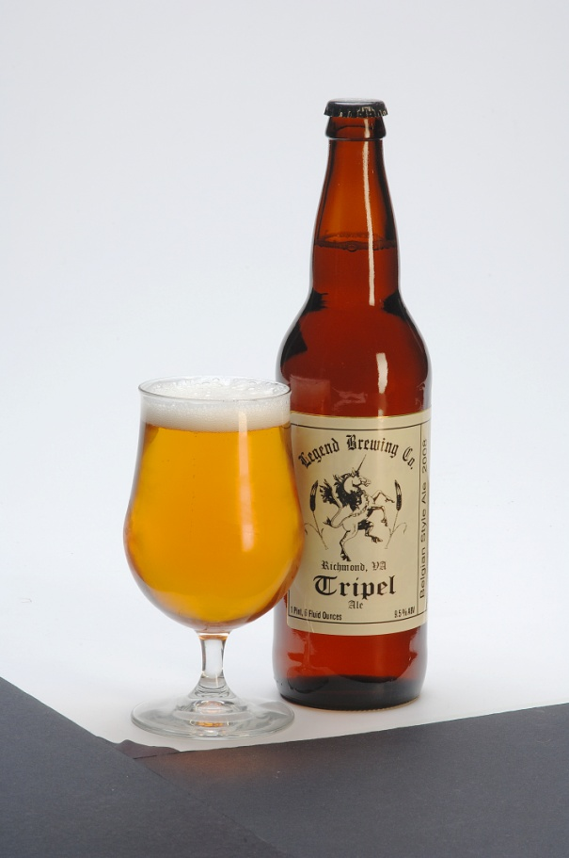
Legend Tripel

The Legend Tripel is brewed on a Belgian abbey-style yeast strain which imparts combinations of banana, clove, apple, pear, and even prominent flavors of bubblegum. This sweetness derives from both the pale malts and high alcohol content. Six months of aging brings a soft smoothness to this sweet, complex ale.
9.0% abv
Available in
½ barrel, 1/6 barrel, 22 oz. bottles

