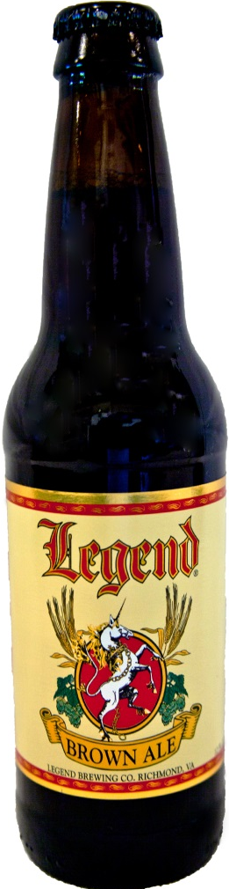
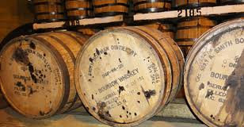
Legend Bourbon Barrel
Brown Ale

Legend has done it now. We have taken our most popular beer and let it soak in A. Smith Bowman Barrels. This has allowed the most enjoyable characteristics of the caramel, toasted nuts, and molasses to be combined with the char and extra sweetness from the barrel to create something that most people on dream of. The rich sweetness is balanced beautifully with steady doses of hops that bring out brilliantly balanced and delicious ale.

